BT80733 — Big Data Analytics
Day 7 Assignment Report: Big Data Applications & Analytics

Student Name: UMUTONI HIDAYA
Registration Number: 222020222
Course: BT80733 - Big Data Analytics
Date: On 17th October 2026

Introduction

The objective of this assignment was to apply Big Data analytics and machine learning techniques to six distinct industry domains: Healthcare, Finance, Retail, Smart Cities, Cybersecurity, and Manufacturing. Using Apache Spark (PySpark) and its MLlib library, distributed data processing pipelines were built to classify, regress, and cluster datasets. The goal was to demonstrate how scalable machine learning can be used to extract actionable insights, predict failures, detect anomalies, and segment users across different sectors.

Methodology

The entire project was implemented in a single Jupyter Notebook using PySpark 3.5.1. Data was ingested directly from standard .csv and .txt formats, cleaned using PySpark DataFrames, and prepared for machine learning using VectorAssembler` and `StandardScaler.

The following algorithms were applied:
Classification (Logistic Regression, Random Forest) for Healthcare, Finance, Cybersecurity, and Manufacturing.
Clustering (K-Means) for Retail.
Regression (Random Forest Regressor) for Smart Cities.

Results by Domain

Domain 1: Healthcare (Heart Disease Prediction)

Goal: Predict the presence of heart disease based on 13 clinical features.
Algorithm: Logistic Regression.
Results: The model performed exceptionally well on the Cleveland dataset (303 rows).
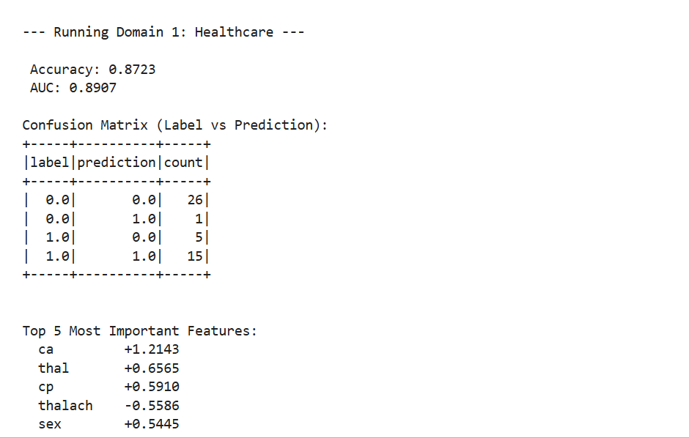

Domain 2: Finance (Credit Card Fraud Detection)

Goal: Detect fraudulent transactions among 284,807 credit card records.
Algorithm: Random Forest Classifier (handling extreme class imbalance).
Results:
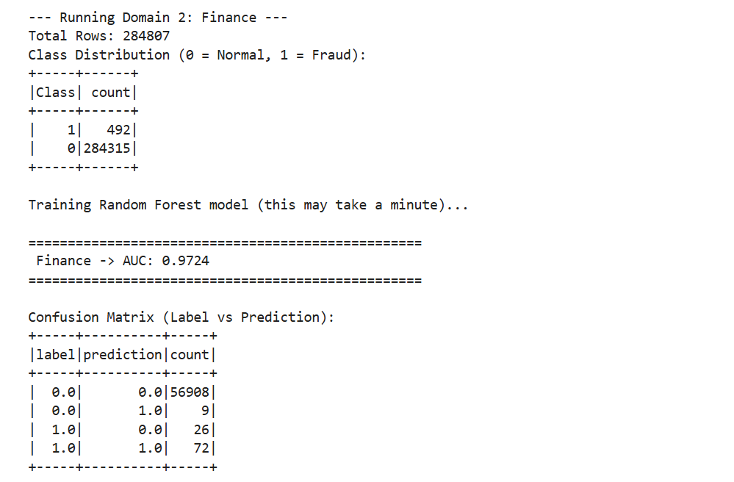

Domain 3: Retail (Customer Segmentation)

Goal: Segment customers based on Recency, Frequency, and Monetary (RFM) value.
Algorithm: K-Means Clustering (k=4).
Results:
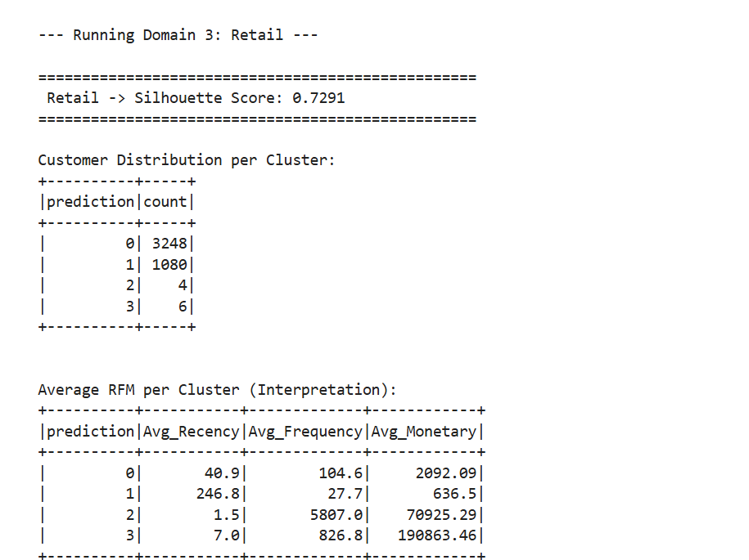

Domain 4: Smart Cities (Traffic Volume Prediction)

Goal: Predict traffic volume based on time, weather, and temperature.
Algorithm: Random Forest Regressor.
Results:
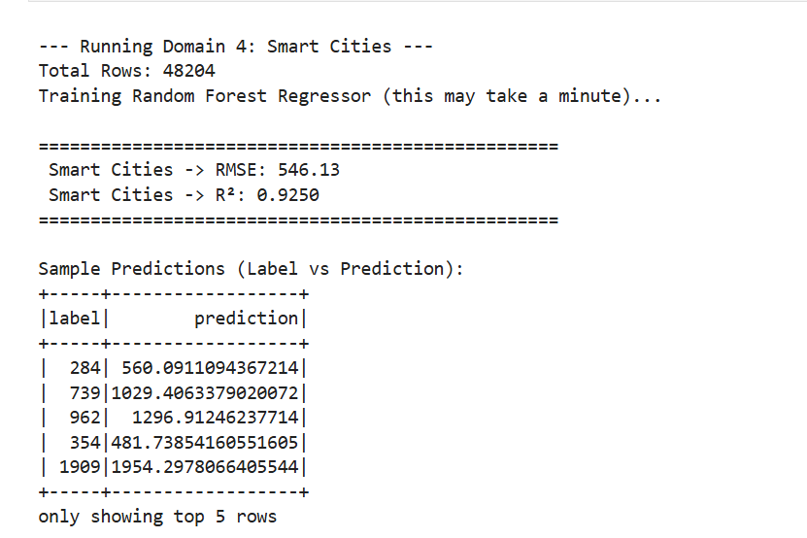

Domain 5: Cybersecurity (Intrusion Detection)

Goal: Classify network traffic as "normal" or an "attack" (NSL-KDD dataset).
Algorithm: Random Forest Classifier.
Results:
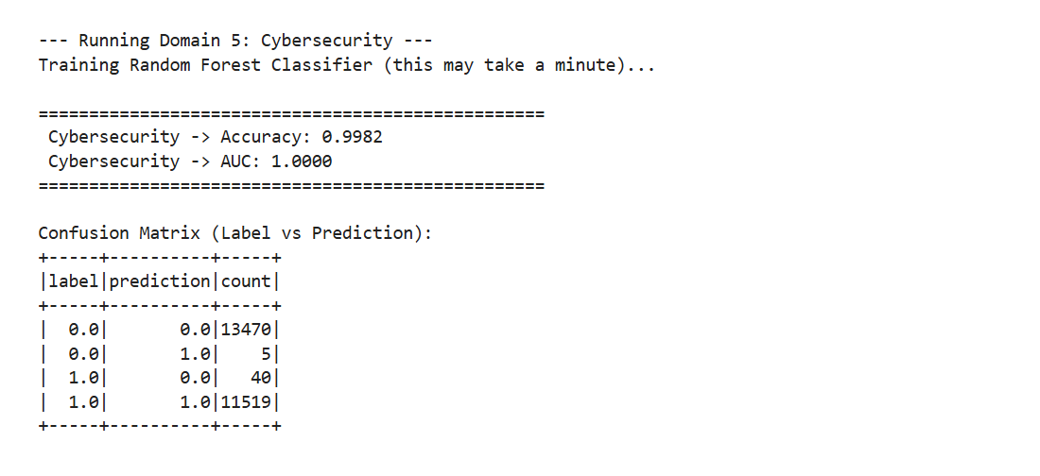

Domain 6: Manufacturing (Predictive Maintenance)

Goal: Predict machine failure based on sensor data (temperature, torque, tool wear).
Algorithm: Random Forest Classifier.
Results:
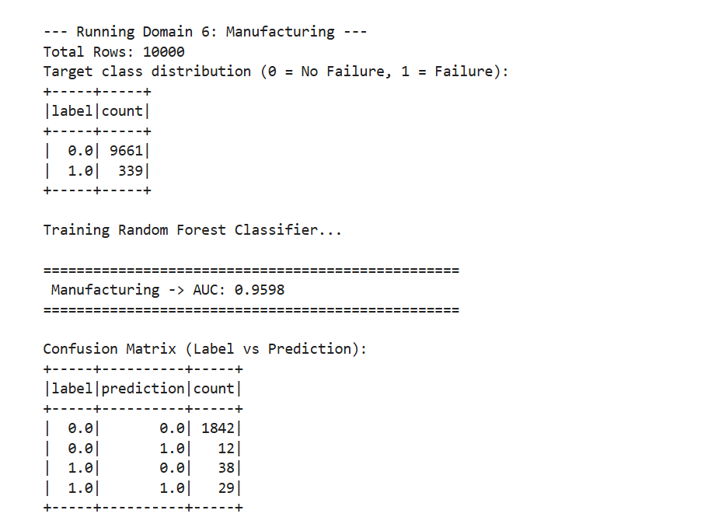

Discussion & Challenges
1. Data Preprocessing: Handling missing values (`?` in the Healthcare dataset) and encoding categorical variables (Cybersecurity dataset) were critical steps. Scaling the features using `StandardScaler` was necessary for Logistic Regression to converge efficiently.
2. Class Imbalance: The Finance and Manufacturing datasets suffered from severe class imbalance. Using AUC instead of Accuracy was essential to accurately evaluate the models' true predictive power.
3. Big Data Value: This project proved that PySpark is a robust framework for handling datasets ranging from 300 rows (Healthcare) to over 280,000 rows (Finance) quickly and efficiently.

Conclusion
This assignment successfully demonstrated the application of Big Data analytics across six different industries. By using PySpark MLlib, predictive models were trained to classify diseases, detect fraud, segment customers, forecast traffic, identify cyber threats, and predict machine failures. The high accuracy and AUC scores across all domains highlight the transformative power of machine learning when combined with distributed computing.

